Componentes Principales
> cor( datos[,4:7])
Read Write Math Science
Read 1.0000000 0.5830513 0.5551651 0.6366188
Write 0.5830513 1.0000000 0.5005453 0.4427985
Math 0.5551651 0.5005453 1.0000000 0.5500513
Science 0.6366188 0.4427985 0.5500513 1.0000000
> cov(datos[,4:7])
Read Write Math Science
Read 98.50706 53.44893 49.84542 55.27468
Write 53.44893 85.30944 41.82263 35.77815
Math 49.84542 41.82263 81.83493 43.52970
Science 55.27468 35.77815 43.52970 76.52903
> cp2<-princomp(datos[,4:7],cor=FALSE)
> summary(cp2)
Importance of components:
Comp.1 Comp.2 Comp.3 Comp.4
Standard deviation 15.0087240 6.7876774 6.3068694 5.31206153
Proportion of Variance 0.6638449 0.1357755 0.1172214 0.08315824
Cumulative Proportion 0.6638449 0.7996204 0.9168418 1.00000000
> loadings(cp2)

Loadings:
Comp.1 Comp.2 Comp.3 Comp.4
Read -0.580 0.524 0.620
Write -0.475 -0.818 -0.323
Math -0.474 0.218 -0.822 0.227
Science -0.462 0.528 0.219 -0.678

Comp.1 Comp.2 Comp.3 Comp.4
SS loadings 1.00 1.00 1.00 1.00
Proportion Var 0.25 0.25 0.25 0.25
Cumulative Var 0.25 0.50 0.75 1.00

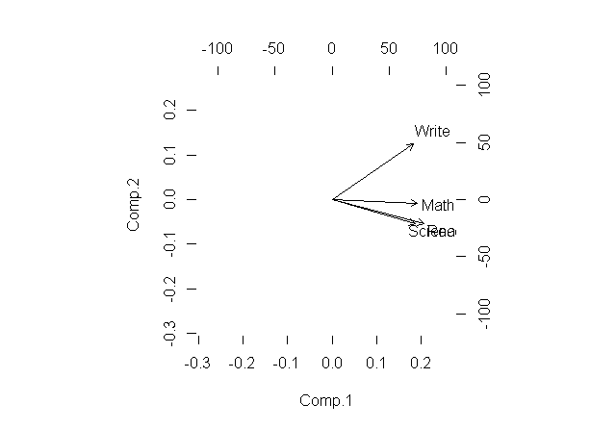
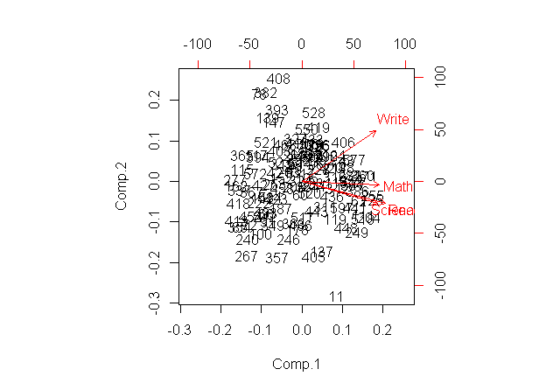

ANALISIS DE FACTORES
Descripcion de las variables
> #general:a non-verbal measure of general intelligence using Cattell's culture-fair test.
> #picture:a picture-completion test
> #blocks:block design
> #maze:mazes
> #reading:reading comprehension
> #vocab:vocabulary

> ability.cov
$cov
general picture blocks maze reading vocab
general 24.641 5.991 33.520 6.023 20.755 29.701
picture 5.991 6.700 18.137 1.782 4.936 7.204
blocks 33.520 18.137 149.831 19.424 31.430 50.753
maze 6.023 1.782 19.424 12.711 4.757 9.075
reading 20.755 4.936 31.430 4.757 52.604 66.762
vocab 29.701 7.204 50.753 9.075 66.762 135.292
>
> factanal(factors = 2, covmat = ability.cov, rotation = "promax")

Call:
factanal(factors = 2, covmat = ability.cov, rotation = "promax")

Uniquenesses:
general picture blocks maze reading vocab
0.455 0.589 0.218 0.769 0.052 0.334

Loadings:
Factor1 Factor2
general 0.364 0.470
picture 0.671
blocks 0.932
maze 0.508
reading 1.023
vocab 0.811

Factor1 Factor2
SS loadings 1.853 1.807
Proportion Var 0.309 0.301
Cumulative Var 0.309 0.610

Factor Correlations:
Factor1 Factor2
Factor1 1.000 0.557
Factor2 0.557 1.000

Test of the hypothesis that 2 factors are sufficient.
The chi square statistic is 6.11 on 4 degrees of freedom.
The p-value is 0.191

