#The data was extracted from the 1974 Motor Trend US magazine,
# and comprises fuel consumption and 10 aspects of automobile design and
#performance for 32 automobiles (1973–74 models).
#A data frame with 32 observations on 11 variables.
#[, 1] mpg Miles/(US) gallon
#[, 2] cyl Number of cylinders
#[, 3] disp Displacement (cu.in.)( displacement in physics, the amount of gas displaced by the strokes of the pistons in an internal combustion engine)
#[, 4] hp Gross horsepower
#[, 5] drat Rear axle ratio (Rear axle ratio
The number of times the rear wheels turn compared to a particular transmission speed. The higher the rear axle ratio, the slower the engine can run and still allow the vehicle to achieve a given speed. Also called Final axle ratio.)
#[, 6] wt Weight (lb/1000)
#[, 7] qsec 1/4 mile time (tiene que ver con velocidad de arranque)
#[, 8] vs V/S
#[, 9] am Transmission (0 = automatic, 1 = manual)
#[,10] gear Number of forward Sears (velocidades)
#[,11] carb Number of carburetors (es el dispositivo que se encarga de preparar la mezcla de aire-combustible en los motores de gasolina.)
> signif(cor(mtcars),3)
mpg cyl disp hp drat wt qsec vs am gear carb
mpg 1.000 -0.852 -0.848 -0.776 0.6810 -0.868 0.4190 0.664 0.6000 0.480 -0.5510
cyl -0.852 1.000 0.902 0.832 -0.7000 0.782 -0.5910 -0.811 -0.5230 -0.493 0.5270
disp -0.848 0.902 1.000 0.791 -0.7100 0.888 -0.4340 -0.710 -0.5910 -0.556 0.3950
hp -0.776 0.832 0.791 1.000 -0.4490 0.659 -0.7080 -0.723 -0.2430 -0.126 0.7500
drat 0.681 -0.700 -0.710 -0.449 1.0000 -0.712 0.0912 0.440 0.7130 0.700 -0.0908
wt -0.868 0.782 0.888 0.659 -0.7120 1.000 -0.1750 -0.555 -0.6920 -0.583 0.4280
qsec 0.419 -0.591 -0.434 -0.708 0.0912 -0.175 1.0000 0.745 -0.2300 -0.213 -0.6560
vs 0.664 -0.811 -0.710 -0.723 0.4400 -0.555 0.7450 1.000 0.1680 0.206 -0.5700
am 0.600 -0.523 -0.591 -0.243 0.7130 -0.692 -0.2300 0.168 1.0000 0.794 0.0575
gear 0.480 -0.493 -0.556 -0.126 0.7000 -0.583 -0.2130 0.206 0.7940 1.000 0.2740
carb -0.551 0.527 0.395 0.750 -0.0908 0.428 -0.6560 -0.570 0.0575 0.274 1.0000
> mod1
Call:
factanal(x = mtcars, factors = 3)
Uniquenesses:
mpg cyl disp hp drat wt qsec vs am gear carb
0.135 0.055 0.090 0.127 0.290 0.060 0.051 0.223 0.208 0.125 0.158
Loadings:
Factor1 Factor2 Factor3
mpg 0.643 -0.478 -0.473
cyl -0.618 0.703 0.261
disp -0.719 0.537 0.323
hp -0.291 0.725 0.513
drat 0.804 -0.241
wt -0.778 0.248 0.524
qsec -0.177 -0.946 -0.151
vs 0.295 -0.805 -0.204
am 0.880
gear 0.908 0.224
carb 0.114 0.559 0.719
Factor1 Factor2 Factor3
SS loadings 4.380 3.520 1.578
Proportion Var 0.398 0.320 0.143
Cumulative Var 0.398 0.718 0.862

Test of the hypothesis that 3 factors are sufficient.
The chi square statistic is 30.53 on 25 degrees of freedom.
The p-value is 0.205
###################
Call:
factanal(x = mtcars, factors = 3, rotation = "none")
Uniquenesses:
mpg cyl disp hp drat wt qsec vs am gear carb
0.135 0.055 0.090 0.127 0.290 0.060 0.051 0.223 0.208 0.125 0.158
Loadings:
Factor1 Factor2 Factor3
mpg -0.910 0.137 -0.136
cyl 0.962 -0.135
disp 0.937 -0.174
hp 0.875 0.292 0.147
drat -0.689 0.453 0.175
wt 0.858 -0.382 0.242
qsec -0.591 -0.754 0.177
vs -0.809 -0.309 0.164
am -0.522 0.719
gear -0.459 0.729 0.365
carb 0.594 0.517 0.471
Factor1 Factor2 Factor3
SS loadings 6.448 2.465 0.565
Proportion Var 0.586 0.224 0.051
Cumulative Var 0.586 0.810 0.862

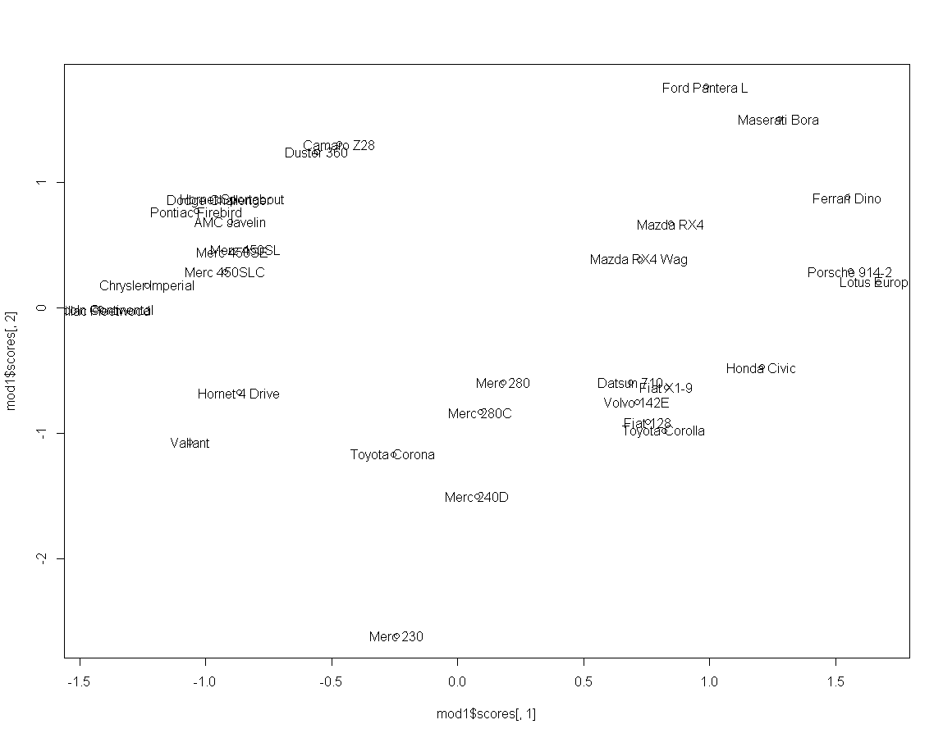
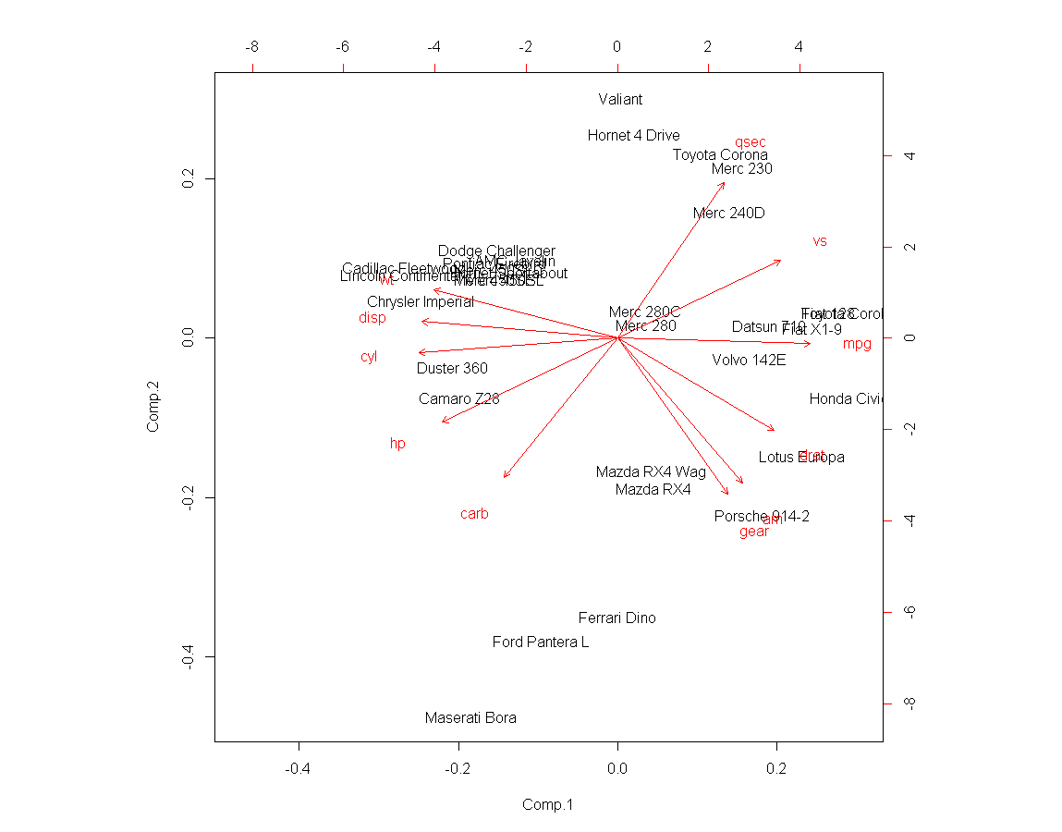
factanal(x = mtcars, factors = 4, rotation = "none")
Uniquenesses:
mpg cyl disp hp drat wt qsec vs am gear carb
0.145 0.039 0.005 0.117 0.273 0.054 0.071 0.227 0.177 0.148 0.005
Loadings:
Factor1 Factor2 Factor3 Factor4
mpg -0.867 0.217 -0.165 0.170
cyl 0.895 -0.272 -0.120 -0.266
disp 0.877 -0.471
hp 0.924 -0.162
drat -0.540 0.550 -0.181 0.316
wt 0.820 -0.375 0.365
qsec -0.641 -0.299 0.648
vs -0.786 0.348 0.179
am -0.378 0.609 -0.481 0.280
gear -0.246 0.776 -0.265 0.345
carb 0.783 0.617
Factor1 Factor2 Factor3 Factor4
SS loadings 5.985 2.233 1.079 0.440
Proportion Var 0.544 0.203 0.098 0.040
Cumulative Var 0.544 0.747 0.845 0.885
Test of the hypothesis that 4 factors are sufficient.
The chi square statistic is 11.7 on 17 degrees of freedom.
The p-value is 0.818
###################
Call:
factanal(x = mtcars, factors = 4, rotation = "varimax")

Uniquenesses:
mpg cyl disp hp drat wt qsec vs am gear carb
0.145 0.039 0.005 0.117 0.273 0.054 0.071 0.227 0.177 0.148 0.005

Loadings:
Factor1 Factor2 Factor3 Factor4
mpg 0.640 -0.481 -0.423 -0.185
cyl -0.606 0.720 0.247 0.114
disp -0.652 0.573 0.167 0.463
hp -0.259 0.733 0.453 0.272
drat 0.808 -0.263
wt -0.742 0.264 0.408 0.400
qsec -0.194 -0.925 -0.188
vs 0.272 -0.805 -0.208
am 0.898
gear 0.896 0.220
carb 0.517 0.846
Factor1 Factor2 Factor3 Factor4
SS loadings 4.203 3.531 1.490 0.514
Proportion Var 0.382 0.321 0.135 0.047
Cumulative Var 0.382 0.703 0.839 0.885
Call:
factanal(x = mtcars, factors = 4, rotation = "promax")

Uniquenesses:
mpg cyl disp hp drat wt qsec vs am gear carb
0.145 0.039 0.005 0.117 0.273 0.054 0.071 0.227 0.177 0.148 0.005

Loadings:
Factor1 Factor2 Factor3 Factor4
mpg 0.529 0.197 -0.335 -0.130
cyl -0.502 -0.609
disp -0.252 -0.301 -0.270 0.771
hp -0.491 0.228 0.348
drat 0.816 0.165
wt -0.478 0.171 0.198 0.570
qsec -0.321 1.041
vs 0.141 0.788
am 0.957 -0.271
gear 0.961 0.287
carb 0.133 -0.188 0.996 -0.160

Factor1 Factor2 Factor3 Factor4
SS loadings 3.470 2.611 1.370 1.093
Proportion Var 0.315 0.237 0.125 0.099
Cumulative Var 0.315 0.553 0.677 0.777

Factor Correlations:
Factor1 Factor2 Factor3 Factor4
Factor1 1.000 0.214 0.627 0.706
Factor2 0.214 1.000 0.321 0.638
Factor3 0.627 0.321 1.000 0.652
Factor4 0.706 0.638 0.652 1.000

Nombre:__________________________________________________________________

- Escribe las variables mpg y disp usando los dos modelos de tres factores que se te dan.

- Cual es la comunalidad para mpg? cual para disp?

- Para este modelo de tres factores ¿Qué variable es la mejor explicada por este modelo de tres factores? ¿Cuál la peor?

- La primer grafica representa a los scores de los dos primeros factores comunes, la segunda es un biplot de componentes principales, interpreta los factores comunes.

- Que diferencias encuentras entre los modelos de tres y de cuatro factores?

- Por que el modelo de cuatro factores ultimo (promax) explica menos varianza total que los otros dos???

