> breast
V1 V2 V3 V4 V5 V6 V7 V8 V9 V10 V11 V12 V13
1 1 49 0 2 3 7 0 6 2 15 1 1 52.46
2 0 59 0 2 2 6 3 7 2 17 1 1 60.83
3 0 49 2 0 6 8 4 9 0 11 1 0 48.70
4 0 58 0 2 1 1 1 7 3 14 1 1 57.33
5 1 49 0 2 1 0 0 3 0 13 0 1 64.26
6 1 43 0 2 0 2 0 4 0 11 1 0 53.90
7 0 46 1 1 4 7 0 8 1 16 1 1 52.45
8 0 59 0 2 7 6 3 4 0 14 1 1 66.18
9 0 53 0 1 4 8 0 1 2 14 1 0 49.54
10 0 51 1 0 4 3 0 7 1 11 1 1 53.88
11 0 50 2 0 10 0 0 3 1 21 0 0 58.46
12 1 50 1 1 3 8 4 2 0 16 1 1 50.22

> daisy(breast,metric="euclidean")
Dissimilarities :
1 2 3 4 5 6 7 8 9 10 11
2 13.676875
3 8.895932 17.920293
4 12.235886 7.297260 16.415752
5 14.499655 13.991601 19.952784 12.610508
6 9.852594 19.596553 13.602941 16.394051 12.463130
7 4.358910 16.069362 8.605957 14.993812 15.667677 9.904671
8 18.006621 8.696120 21.320188 12.740585 13.736317 22.176528 19.987819
9 7.451604 15.081913 10.895210 13.553011 17.851566 13.964584 10.698977 18.705336
10 6.856851 13.277895 9.101231 9.638594 12.559634 9.899515 8.369283 16.318395 9.840508
11 13.856406 15.447230 18.172991 15.075706 13.807244 16.905431 13.824619 15.987445 15.765989 13.637316
12 6.783627 15.250315 9.503178 14.749647 17.179104 12.471664 8.773420 19.176068 6.201806 10.459235 15.129362

> daisy(breast,metric="gower",type = list(asymm = c(1, 11,12), ordratio = c(4:9)) )
Dissimilarities :
1 2 3 4 5 6 7 8 9 10 11
2 0.2654353
3 0.5442631 0.5616970
4 0.2772156 0.1732168 0.6411257
5 0.3005233 0.4532199 0.7114531 0.3754140
6 0.2747435 0.4884329 0.5428127 0.4018005 0.2851815
7 0.2321716 0.3319312 0.3860158 0.3613599 0.4814129 0.4267869
8 0.3496624 0.1669075 0.5119378 0.2901243 0.3844260 0.4498273 0.3895794
9 0.2955727 0.3994253 0.4432575 0.3955206 0.5367553 0.4106997 0.3031091 0.4316766
10 0.3170853 0.3824056 0.3519105 0.3308819 0.4571255 0.4005764 0.1638114 0.4067205 0.3576943
11 0.6268159 0.6751710 0.5557196 0.6368025 0.5347108 0.6216895 0.5064957 0.6648298 0.5520364 0.4364343
12 0.2714417 0.3964923 0.3637555 0.5005803 0.4254448 0.4216430 0.2830124 0.3715620 0.3728490 0.3737834 0.6241733

Metric : mixed ; Types = A, I, I, T, T, T, T, T, T, I, A, A, I
Number of objects : 12

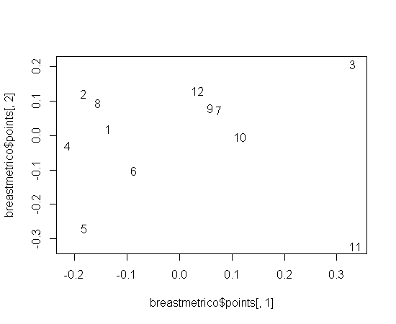

#
breast.distmatrix<-daisy(breast,metric="gower",type = list(asymm = c(1, 11,12), ordratio = c(4:9)) )
breastmetrico<-cmdscale( breast.distmatrix, eig = TRUE )
breastmetrico$GOF
plot(breastmetrico$points[,1],breastmetrico$points[,2],type="n")
text(breastmetrico$points[,1],breastmetrico$points[,2],labels=1:12)

breast.clust1<-agnes(breast.distmatrix,diss="TRUE",method="complete")
plot(breast.clust1)

breast.clust2<-agnes(breast.distmatrix,diss="TRUE",method="single")
