**Ejemplo con una urna de 22 blancas y 4 negras y muestra tamaño 22**

> plot(0:22,dhyper(0:22,22,4,22),type="h")

> cbind(0:22,dhyper(0:22,22,4,22))

[1,] 0 0.000000e+00

[2,] 1 0.000000e+00

[3,] 2 0.000000e+00

[4,] 3 0.000000e+00

[5,] 4 0.000000e+00

[6,] 5 0.000000e+00

[7,] 6 0.000000e+00

[8,] 7 0.000000e+00

[9,] 8 0.000000e+00

[10,] 9 0.000000e+00

[11,] 10 0.000000e+00

[12,] 11 0.000000e+00

[13,] 12 0.000000e+00

[14,] 13 0.000000e+00

[15,] 14 0.000000e+00

[16,] 15 0.000000e+00

[17,] 16 0.000000e+00

[18,] 17 0.000000e+00 siempre hay al menos 18 blancas en la muestra tamaño 22

[19,] 18 4.892977e-01 18 blancas y 4 negras

[20,] 19 4.120401e-01 19 blancas y 3 negras

[21,] 20 9.270903e-02 20 blancas y 2 negras

[22,] 21 5.886288e-03 21 blancas y 1 negras

[23,] 22 6.688963e-05 22 blancas y cero negras

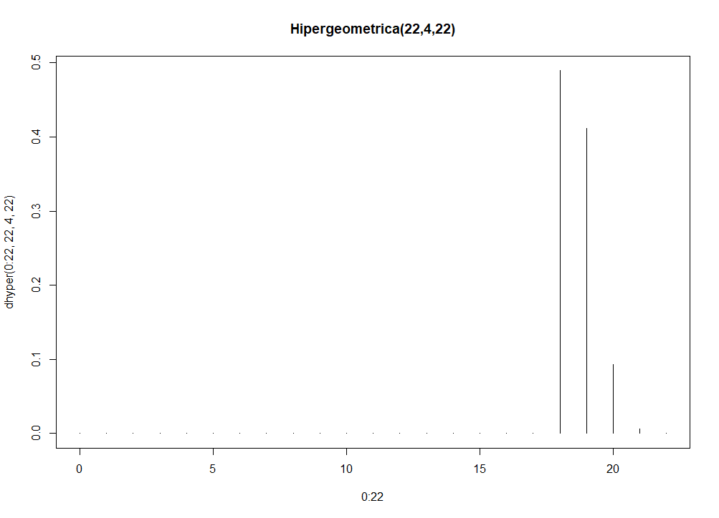

**Ejemplo con una urna de 4 blancas y 22 negras y muestra tamaño 22**

> cbind(0:22,dhyper(0:22,4,22,22))

[,1] [,2]

[1,] 0 6.688963e-05 cero blancas y 22 negras

[2,] 1 5.886288e-03 1 blanca y 21 negras

[3,] 2 9.270903e-02 2 blancas y 20 negras

[4,] 3 4.120401e-01 3 blancas y 19 negras

[5,] 4 4.892977e-01 4 blancas y 18

[6,] 5 0.000000e+00

[7,] 6 0.000000e+00

[8,] 7 0.000000e+00

[9,] 8 0.000000e+00

[10,] 9 0.000000e+00

[11,] 10 0.000000e+00

[12,] 11 0.000000e+00

[13,] 12 0.000000e+00

[14,] 13 0.000000e+00

[15,] 14 0.000000e+00

[16,] 15 0.000000e+00

[17,] 16 0.000000e+00

[18,] 17 0.000000e+00

[19,] 18 0.000000e+00

[20,] 19 0.000000e+00

[21,] 20 0.000000e+00

[22,] 21 0.000000e+00

[23,] 22 0.000000e+00

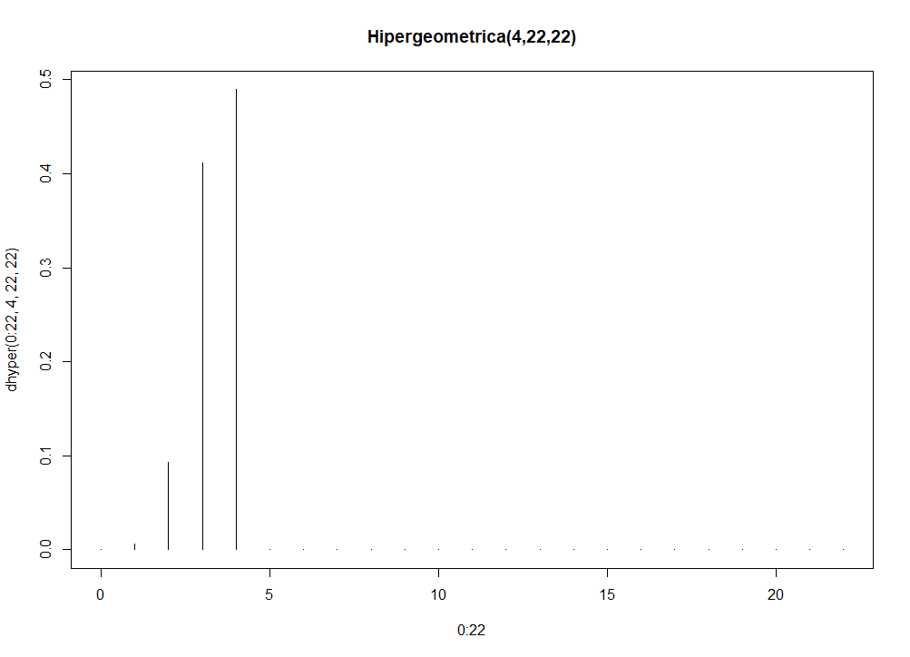

cbind(0:22,dhyper(0:22,17truenean,9 aprueban,22))

[,1] [,2]

[1,] 0 0.000000000 22 apruebe ¡!!! No hay

[2,] 1 0.000000000 21 apruebe ¡!!! No hay

[3,] 2 0.000000000

[4,] 3 0.000000000

[5,] 4 0.000000000

[6,] 5 0.000000000

[7,] 6 0.000000000

[8,] 7 0.000000000

[9,] 8 0.000000000

[10,] 9 0.000000000 13

[11,] 10 0.000000000 12

[12,] 11 0.000000000 11

[13,] 12 0.000000000 10 aprobados ¡!!! No hay

[14,] 13 0.159197324 9 aprobados

[15,] 14 0.409364548 8 aprobados

[16,] 15 0.327491639 7 aprobados

[17,] 16 0.095518395 6 aprobados

[18,] 17 0.008428094 5 aprobados

[19,] 18 0.000000000 no hay 18 tronados

[20,] 19 0.000000000

[21,] 20 0.000000000

[22,] 21 0.000000000

[23,] 22 0.000000000